**Task 1: Create a Web App**

Azure App Service is actually a collection of four services, all of which are built to help you host and run web applications. The four services (Web Apps, Mobile Apps, API Apps, and Logic Apps) look different, but in the end they all operate in similar ways. Web Apps is the most commonly used of the four services (Web Apps, Mobile Apps, API Apps, and Logic Apps), and Web Apps is the service that we will be using in this lab.

In this task, you will create an Azure App Service Web App.

1. Sign in to the [Azure portal (https://portal.azure.com)](https://portal.azure.com/).
2. From the **All services** blade, search for and select **App Services**, and click **+ Add**
3. On the **Basics** tab of the **Web App** blade, specify the following settings (replace **xxxx** in the name of the web app with letters and digits such that the name is globally unique). Leave the defaults for everything else, including the App Service Plan.

| **TABLE 1** | |
| --- | --- |
| **Setting** | **Value** |
| Subscription | **Choose your subscription** |
| Resource Group | **myRGWebApp1** (create new) |
| Name | **myDockerWebAppxxxx** |
| Publish | **Docker Container** |
| Operating System | **Linux** |
| Region | **East US** (ignore any service plan availability warnings) |
|  |  |

1. Click **Next > Docker** and configure the container information. The startup command is optional and not needed in this exercise.

**Note**

This is same container that was used in the Container Instances walkthrough to display a hello world message.

| **TABLE 2** | |
| --- | --- |
| **Setting** | **Value** |
| Options | **Single container** |
| Image Source | **Docker Hub** |
| Access Type | **Public** |
| Image and tag | **microsoft/aci-helloworld** |
|  |  |

1. Click **Review + create**, and then click **Create**.

**Task 2: Test the Web App**

In this task, we will test the web app.

1. Wait for the Web App to deploy.
2. From **Notifications** click **Go to resource**.
3. On the **Overview** blade, locate the **URL** entry.

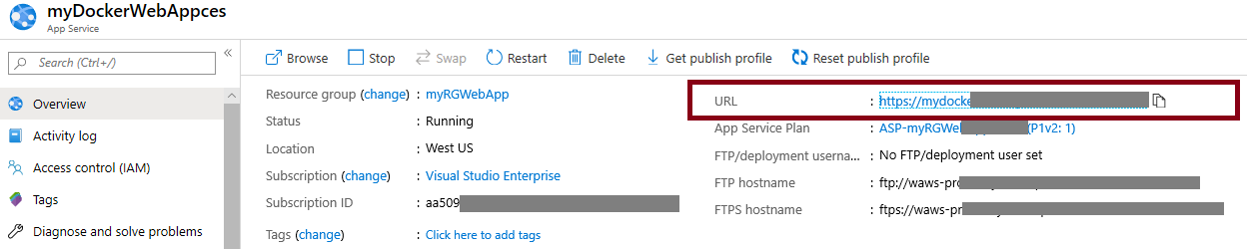

1. Click on the **URL** to open the new browser tab and display the Welcome to Azure Container Instances page.

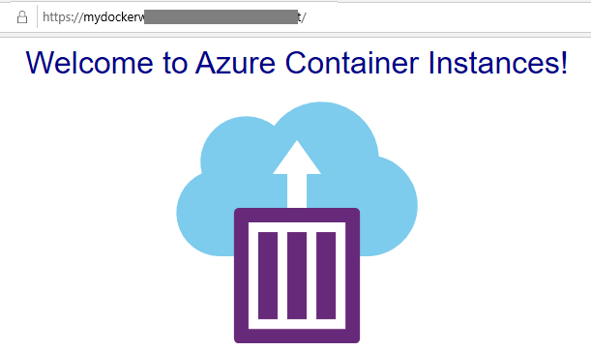

1. Switch back to the **Overview** blade of your web app which includes several charts. If you repeat step 4 a few times, you should be able to see corresponding telemetry being displayed in the charts. This includes number of requests and average response time.